### **Install JDK 1.8 first**

**STS TOOL:  
  
Step 1:** Download the STS tool from the

**Step 2:** Extract the Zip file

**Step 3:** Follow the path “sts-bundle\sts-3.9.1.RELEASE”

**Step 3:** Run the sts application.

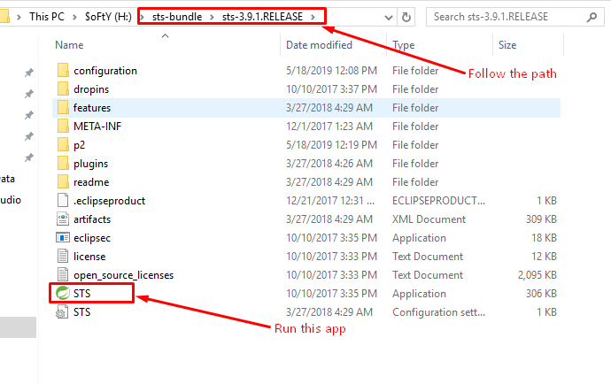

**Step 1)** Run your sts tool or Eclipse.

**Step 2)** Click to file at the top left corner and click to import.

**Step 3)** Select Maven> Existing Maven Project and click on the Next button.

**Step 4)** Browser your project from the location and click next then finish and wait until the import process is finished.

**Step 5)** Right-click on the project and select properties from the bottom.

**Step 6)** Select “Java build path” Then “Libraries”

* Edit **“JRE System Library”** and select **“Execution Environment”** as 1.8 and click to finish.
* Click on “Order and Export” Check the “JRE System Library” checkbox and click to apply.

**Step 7)** Select **“Project Facets”** from the properties and change the java version to 1.8 and click to apply and finish.

APACHE TOMCAT:  
  
Step 1) Download tomcat 8.5

Step 2) Extract the File and copy it at any location in your machine for example “C drive”.

Step 3) Again Switch to sts tool/Eclipse and search for server window. Follow the path to find the server window

=>Windows=>Show view=>Others=> Server.

Step 4) Right click in the server window and select

New=>server=>Apache=>Tomcat 8.5 Server=>Next.

Step 5) Browse the tomcat folder which we had copied in “C drive”.

Step 6) Click to Next and Finish.